evaluation report blended learning
Consultancy on Situation Assessment for ICT & Blended learning at SPH, NIPH, Cambodia

Structure of the report

- Introduction
- Methods
  - When & where did we do the assessment
  - How did we do the assessment
  - Materials used
  - Overall method used
  - Why did we address the target group like it
  - Methods used for faculty
  - Method used for IT team
  - Method used for Students
  - Method used for administration
  - Limitations of the method
- Results
  - Axis-1 Target group
    - Insights from the students
  - Axis-2 Internal factors
    - Facilities (ICT) for the blended learning program
    - Platform availability and possibility
    - Internet & Connectivity
    - Faculty point of view
    - IT technical observation
    - Skill level
      - IT
      - Students
      - Faculty
    - Mindset (Motivation)
      - IT
      - Student
      - Faculty
    - Teaching methods & Learning activities
  - Axis-3 External factors
    - Expectation
    - MOH view
    - Accreditation
    - Other similar online training program
    - Possible Alliance with Institutions or universities
  - Existing system currently situation
  - SWOT analysis
- Discussions
  - Identifying the training program
  - Time allocation
  - Language
  - Key challenges
  - Key learnings
  - Integrating the existing system

- Recommendation
  - Key finding
  - Communication process
  - Professional development needs
  - Instructional method
  - Resource requirement
  - Workplan

Introduction

The National Institute of Public Health (NIPH) through the School of Public Health provides various masters and short courses. Most of these programs are currently conducted during the weekend classes. There are many students who travel long distances to attend the program, this is really challenging for them because they will need to take care of the extra like accommodation, transportation, etc. Many of the students share common rooms to save some money. That is the reason the School of Public Health would like to implement a blended learning program, they believe that this will encourage more people from remote areas to join their training programs related to public health.

The idea of blended learning is to combine the best practices of both components, the face to face and online training to help the students to achieve the learning outcomes in a more efficient way. For example, if a course consists of both theoretical and practical sessions. The theoretical part can be delivered online and when the participants come to the face to face session the practical aspects can be tackled.

In order to achieve this goal, an assessment was requested, to evaluate if the readiness of the school to implement the blended learning program. To be aligned with our proposal, our analysis will be focused on three axis (Target group, internal factors & external factors) In this document, we try to explain the methods that we have used and the rationale behind, the limitations that we had, the data that we have collected, the conclusions and some recommendations

Methods

As we described in the introduction. Our analysis will be focused on three axes (Target group, internal factors & external factors). One of the main difficulties to measure is whether the staff have the skills to design online learning activities (that includes online assessments) That is the reason we wanted to have a one on one interview. Therefore, seven weeks before our arrival at the institute, we started to coordinate (exchanging emails) to prepare our visit in order to make our task as efficient as possible. During the first days of our mission, we managed to schedule the meetings to interview as many faculty members as possible. All the assessment was scheduled with the support from Professor Heng Sopheab (Head of the Academic Affairs) and Miss Heng Sotheara (coordinator) at the School of Public Health.

The assessment was done between 24-June-2019 to 10-July-2019. We have used different methods based on the three axes. To understand the current situation in the institute. The primary data collection was done using the following methods.

Axis-1: Target audience(Students)
We conducted a digital polling survey to identify the important factors to consider in order to design the blended learning program.
A total number of students who attended the survey was 43.

Axis-2: Internal Factors

    - Teaching staff. We had meetings with the available staff and conducted a scenario-based interview to measure the knowledge, skills & attitude to organise the blended learning program.

With the seven faculties, one of the challenges was to understand what current knowledge of blended learning is and the application of the same. Rather than doing a survey, the approach was to give a scenario. Faculty have to define what a blended learning lesson plan would look like based on the scenario.

The example of creating a soup was taken so that the differentiation between what can be done online and what can be done face to face. We continued to have a detailed discussion with the faculty on what is the learning outcome of the course and how can we achieve the same. We nudged the faculty to think through different types of learning activity to run online and the evaluation process of the defined learning outcomes.

    - IT staff. We have interviewed three of the IT team members, challenged and train them in order to find out the internal capacity. Series of challenges were presented to see the readiness to manage and renter the blended learning program

    - Administrative staff. Five of the main staff that are involved in the administration process (registration, certificate) were interviewed additional information was requested (course brochure, course list, course management document, website materials, administration system) was looked to validate the information shared by the team.

Axis-3: External factors
We had meetings with the administrative staff & senior management at NIPH to understand the role of MOH in the functioning of the institute. The meeting with the HR team to understand the hiring process and how the budgets are allocated, we further discussed the different roles in the institute. The possibility of collaboration was explored with University of Nagasaki & ITM. We also did an exploration online to compare if there are other institutes who are running similar training programs.

Results

Axis-1: Target audience.

70% of the students prefer Blended Learning, 26% Face-to-Face and 4% pure online. 82% of the participants prefer to download the content to access it without internet. They mainly use Facebook 30%and telegram 30% as messenger. Gmail is used by the majority of the students 74%. 51% of the students don’t update their antivirus. 94% at least have an intermediate level of computer skills (browse, Microsoft office Basics). 62% uses iPhones

    - Axis-1 Where do the students live: In our survey of the current batch, 74% of the students are coming from the city and only 26% is from the province.

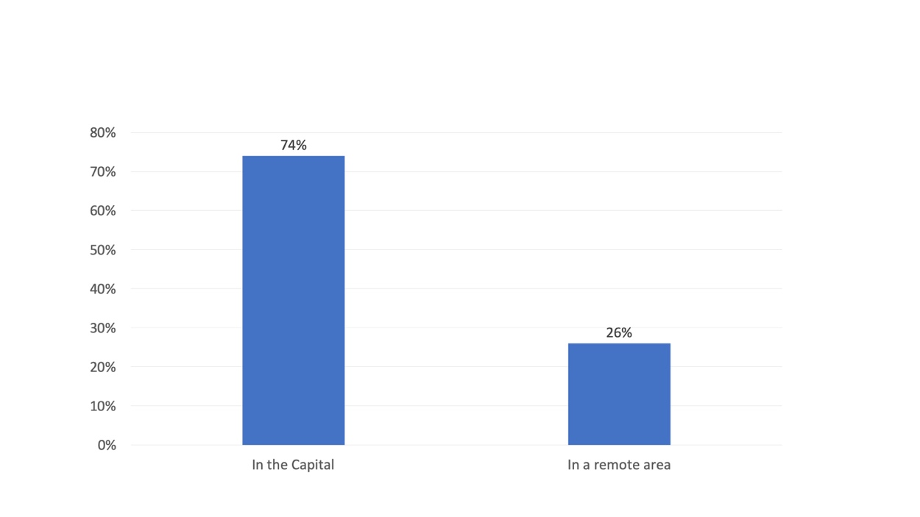

Chart-1: Where the students live

    - Axis-1 Salary Distribution. The salary range varied a lot from each other. Please see the Chart-2 for details.
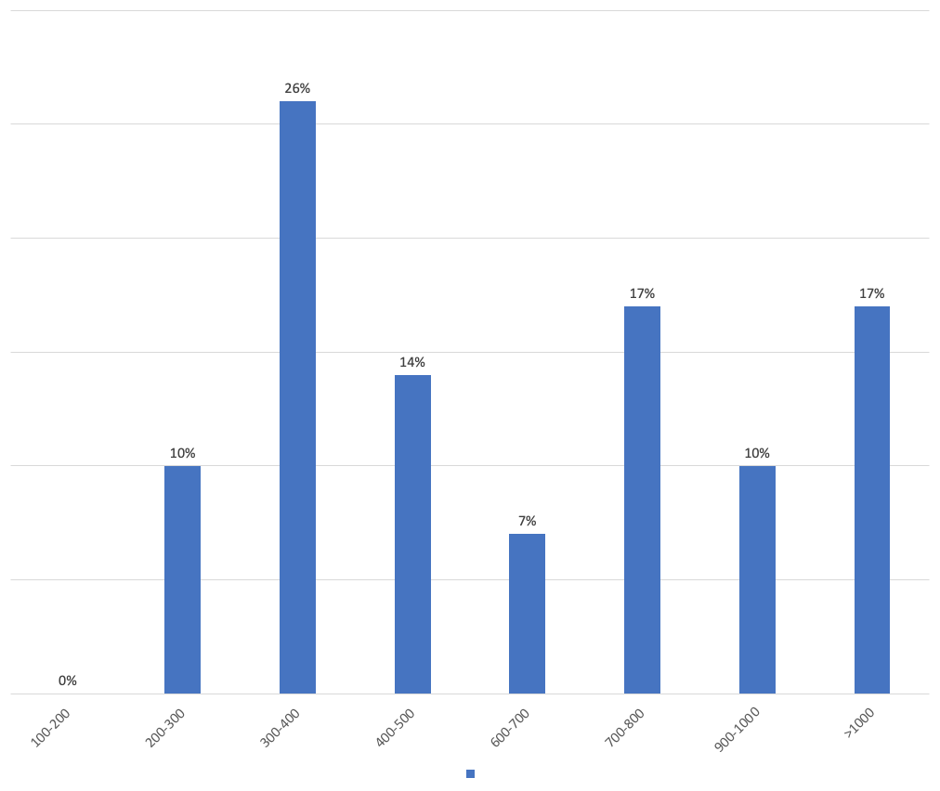
Chart-2: Salary range of the students

    - Axis-1 Students access to internet. 31% of the students use smart and 60% cellcard.67% consider that is a stable connection. We tested the 2 mobile providers and the internet was fast enough to watch videos. The majority of the students 39% pays 5USD for internet (4Gb), only 12% consider that the amount of data is not enough but they don’t they don’t top up. the students have more than 1 source to access internet.
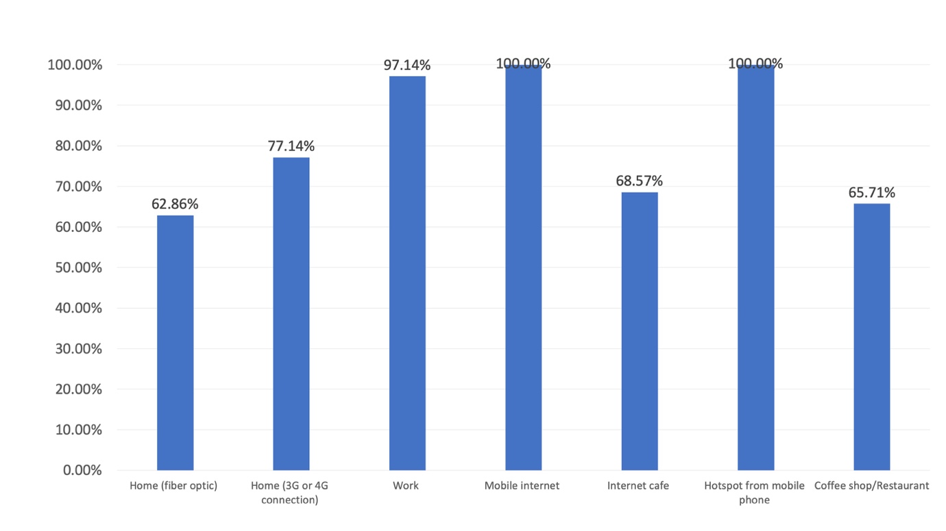

Chart-3: Students access to internet

    - Axis-1 Students can use a laptop or desktop. 100% of the students can use their own laptop or use the desktop or laptop from work. 16% of the users have a MacOS laptop

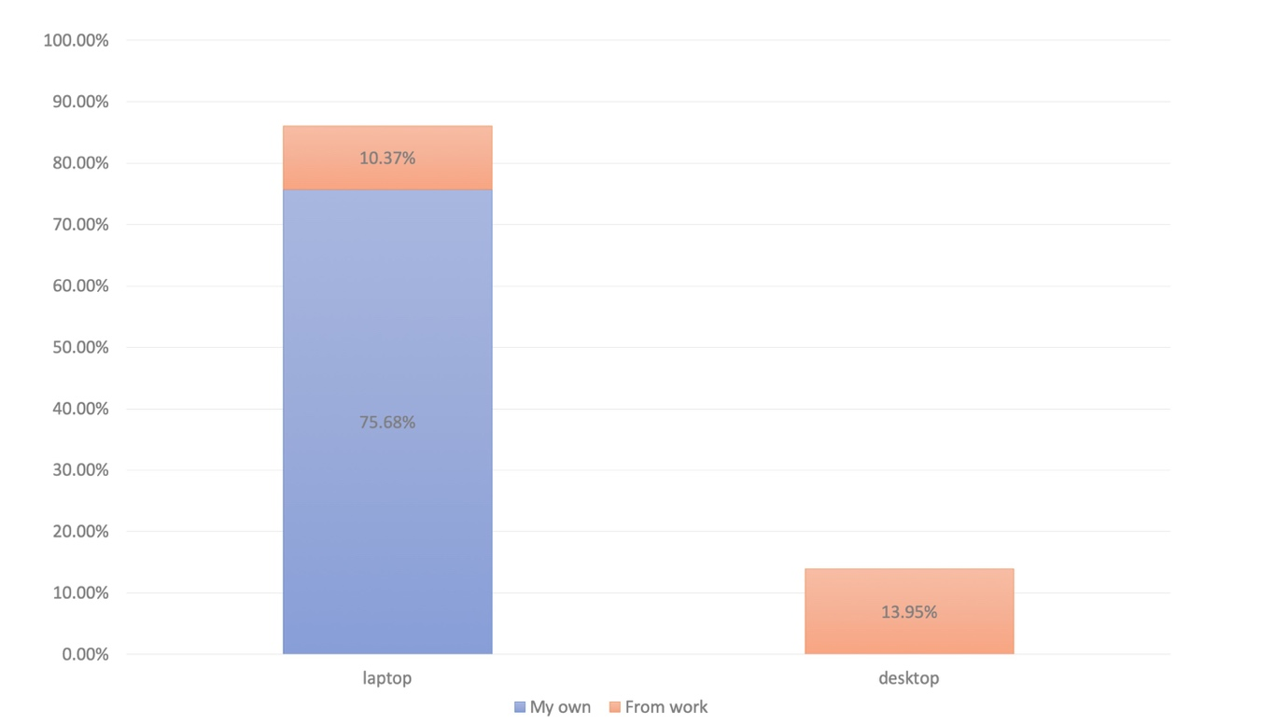
Chart-4: Students can use a desktop or laptop

    - Axis-1 Days of the weeks that can study online. The majority will start to study online from Thursday until Monday

Chart-5: Students days of the week that will study online

Axis-2 Internal factors

- Axis-2 Facilities (ICT) for the blended learning program: For successful implementation of the blended program the ICT facilities have to be looked from a school perspective and the ability of students to access the same.

- Institution ICT facilities: Currently the institute has average internet connectivity (XXX). To run a successful blended program the IT and the facilitation team will require reliable connectivity to host the program and to be able to monitor the students progress.

- The institute is equipped with the zoom conferencing system which can be used for facilitating the online blended program.

- Average students (53%) spend 5$ and more for internet connectivity. It's important to consider the affordability of the students while designing the training programs. ..

- Average of 89% of the students have 4GB or more data available per month. But only 39% of the students have available data towards the end of the month. So while designing the training program we will need to consider the affordability of the students to the internet connection. 61% of the students will need to update the internet connectivity for them to incur the extra cost of the blended program. The design of the program should consider the affordability of the students to access the content.

- There could be also the possibility of collaborating with popular mobile internet provider to provide additional data for some extra cost.

- Axis-2: Faculty point of view: Faculty take on the blended learning program is really important for the successful implementation of the training programs.

  - 57% of the faculty requires no training in the understanding of the blended learning programs. They have done some kind of online courses before and are familiar with the concepts. 43% of the faculty require training on blended learning. There a need to conduct an orientation session to the faculty before starting the training program.

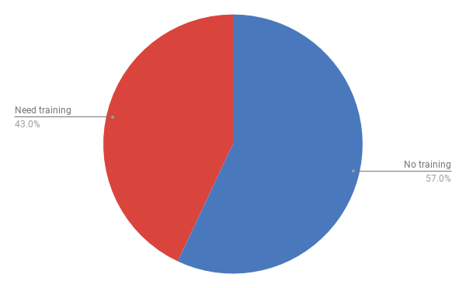
Chart-8: Knowledge of blended learning program

  - 71% of the faculty felt that there is a need for starting the blended learning program in the institute. They felt that implementing a blended learning program will help upscale the course to a larger group of people and improve the learning experience of the students. 29% of the faculty felt that the kind of course that they are running is more practical based and cannot be adapted to the blended learning program.

  - There is a need to consider the kind, of course, that needs to be adapted to the online environment. The course both theoretical and practical component to be considered for developing the program. The consensus of the faculty is important before implementing the program.

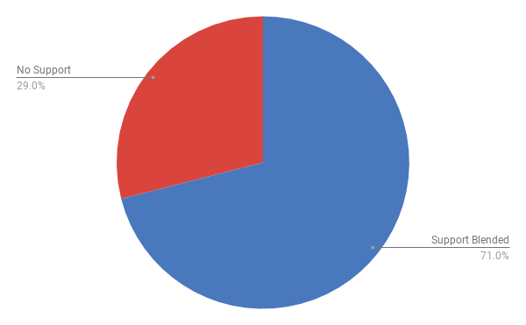
- Chart-9: Support for blended learning program

IT Skills

IT team skills level
    - The IT team was given a series of challenges as part of the skills of the team. Each team members presented a different level of interest in terms of implementation of the program. The team was equipped with the skills to identify and set up the right kind of LMS (Learning Management System) on to the test platform. The LMS was identified based on the comparison of various features and requirement of the institute.

    - The IT team was also given a challenge to creating activities within the LMS platform. The team has the basic skills to get started. The team will require further training related to the creation of learning activities to create a successful blended learning program.

    - It was also observed that the IT team is not stable and each of the members are allocated based on the contract. Because of the contract nature of the employment retention rate of the staff is also very less. This creates a huge challenge in implementation of the training programs.

Students skill level

  - IT skills for the students is essential as part of implementation of the blended learning program. 98% of the students also considered them above the intermediate level of usage of computer.

Students definition was done based on the following maxtris.

Beginner (I just browse, search information on the web and access facebook).
Intermediate (Beginner +I use PowerPoint, word).

Advance (Intermediate + I know how to use excel formulas, I can solve my computer problems and I know how to use statistical programs like R or stata)

  - This shows the students are equipped to follow the blended learning class. A small percentage of the students will need basic training get them oriented to the program which can be done online or face-to-face on the feasibility.

  - 91% of the students spend more than five days a week on the digital devices. This is a significant amount of time during the week which needs to be considered while designing the blended learning program. The learning activities should be designed in such a way that students should be able to access the content anytime during the week.

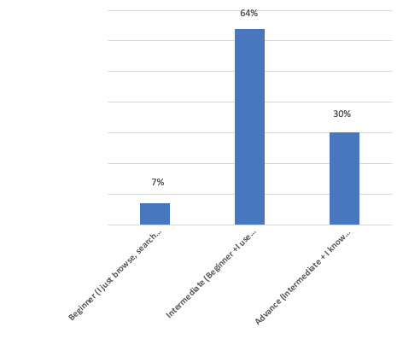
Chart-10: computer proficiency of the students

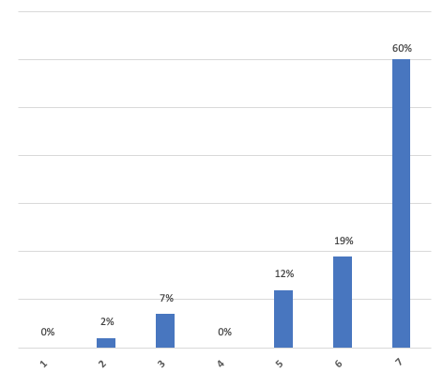
Chart-11: Usage of computer during the day

  - The aditional advantage for implementing the blended learning program is that more than 58% of the participants have already been exposure to online courses.

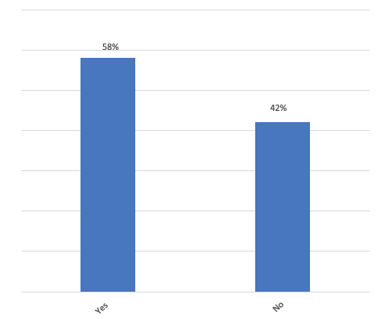
Chart-12: Students who have done online course before

Faculty skill level

  - When it comes to design the learning activity and the evaluation for the training program for the blended learning environment only 14% of the faculty was able to articulate ways to design for the blended learning program. The evaluation methods in an online environment were challenging for the faculty members. There is a need for the training of the faculty member for the process of content development and how to alight the evaluation with the same.

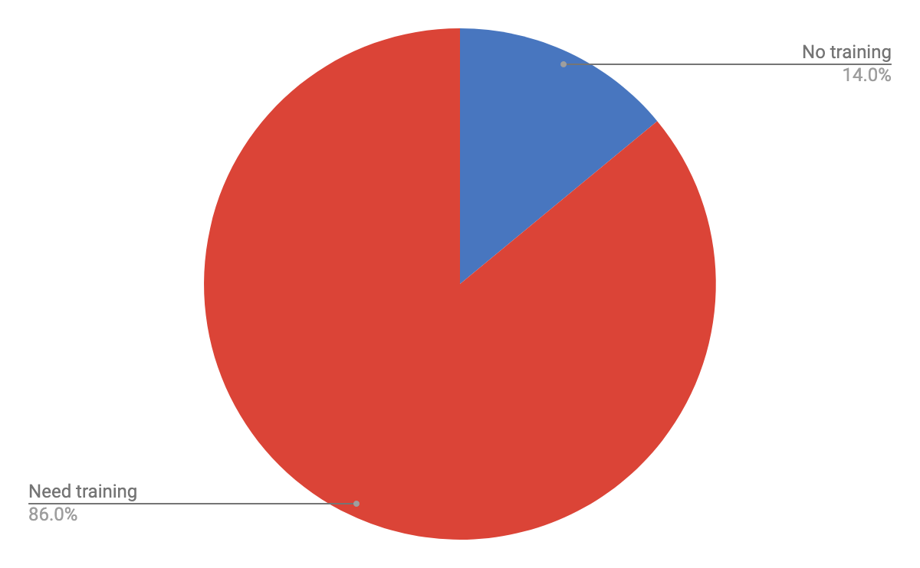
Chart-13: Faculty capacity to design a learning activity + evaluation

Mindset (Motivation)

